**PROJECT REPORT TEMPLATE**

**1 INTRODUCTION**

*1.1 Overview*

The global air transportation network comprises airlines, airports, and air traffic control systems, connecting people and goods worldwide. It drives economic growth, tourism, and international trade. Despite its benefits, the industry faces challenges like environmental impact and congestion. Ongoing advancements and global cooperation are crucial for its sustainable future.

*1.2 Purpose*

The global air transportation network exists to enable swift and efficient movement of people, goods, and services worldwide. It fosters international trade, tourism, cultural exchange, and facilitates rapid response during emergencies, contributing significantly to global connectivity and economic growth.

**2 PROBLEM DEFINITION AND DESIGN THINKING**

*2.1 Empathy Map*

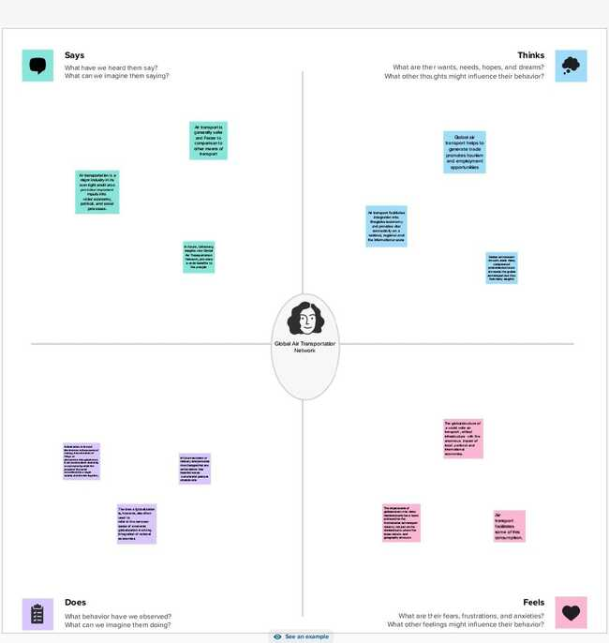

*2.2 Ideation and Brainstorming Map*



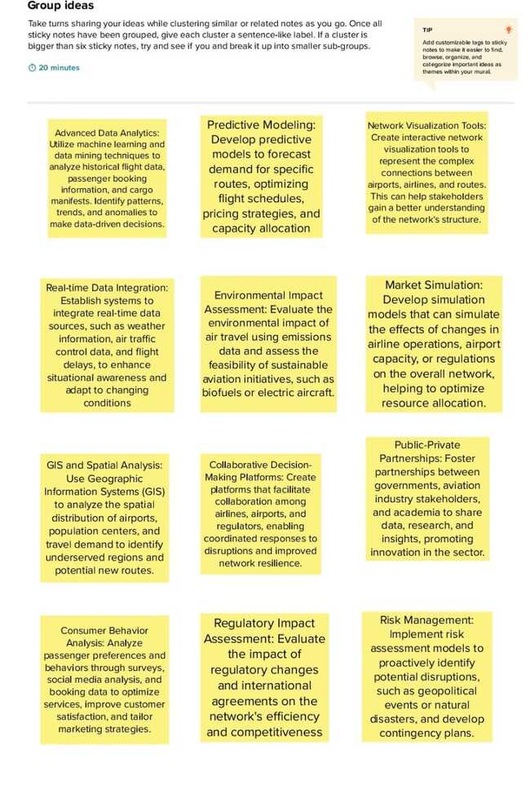



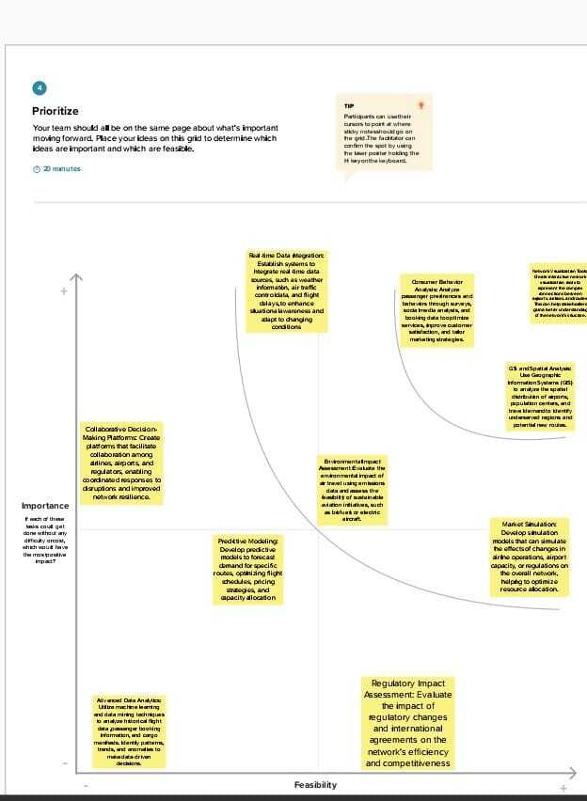

**3 RESULT**

*3.1 Sheet creation*

**World map showing details of all airports within a country**

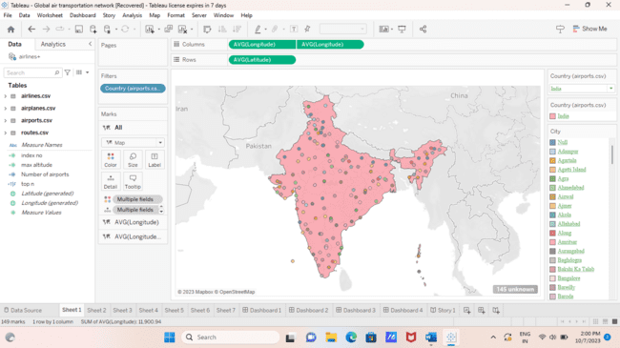

**Number of airports within the country**



**Airports at higher altitude within a country**

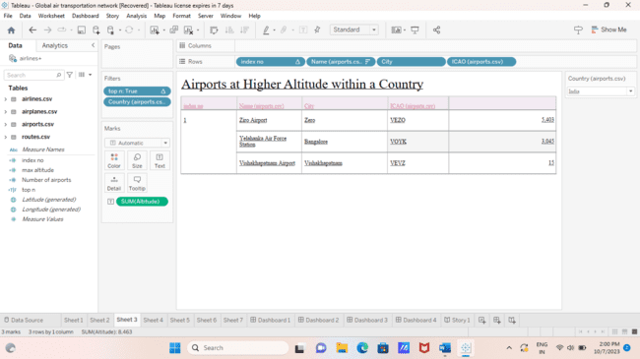

**Airports at higher altitude in world**

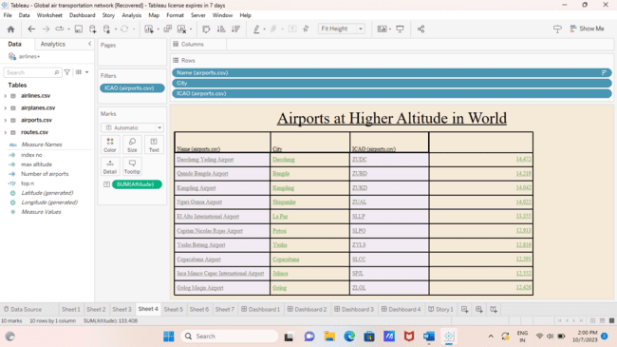

**Airlines within a country**



**Number of flights from airport**



**Country with maximum number of airports**



**Dashboard and story creation**

**DASHBOARD 1**

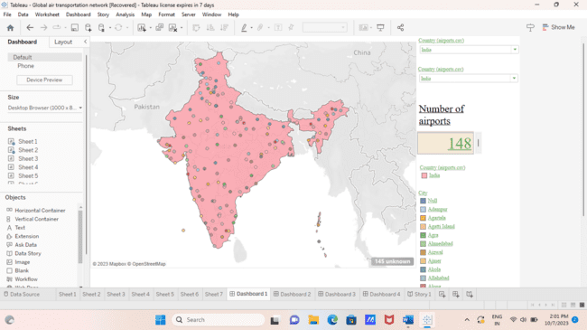

**DASHBOARD 2**

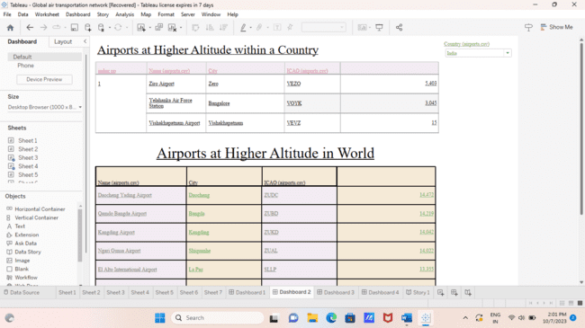

**DASHBOARD 3**



**DASHBOARD 4**

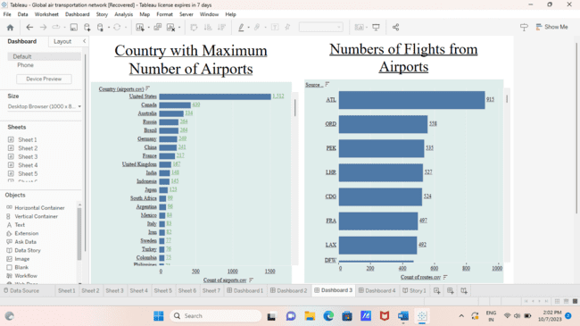

**STORY 1**

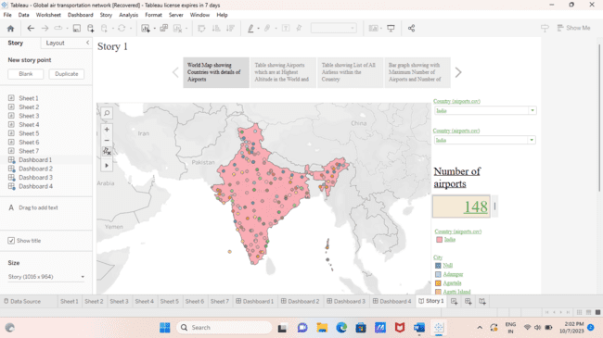

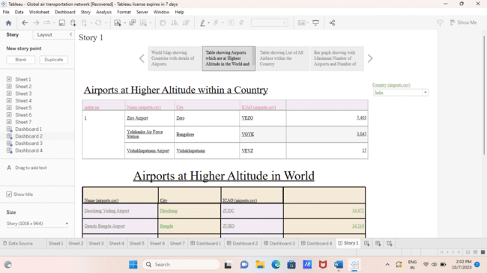

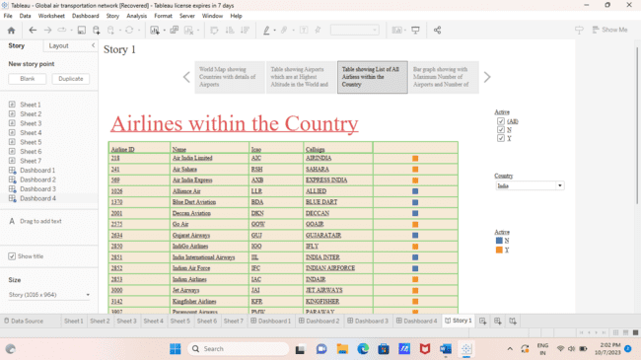

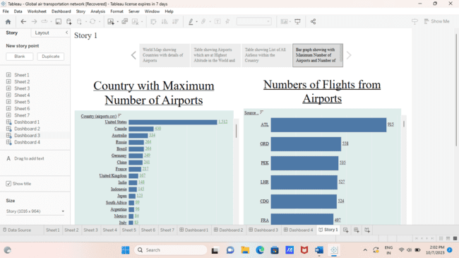

**4 ADVANTAGES AND DISADVANTAGES**

*Advantages:*

• Fast travel

• Accessibility

• Economic impact

• Cultural exchange

• Emergency response

• Technological innovation

• Environmental efficiency

• Globalization benefits

• Personal convenience Disadvantages:

• Environmental impact

• Congestion and delays

• Security concerns

• Cost

• Noise pollution

• Infrastructure maintenance • Dependency on fossil fuels

• Limited accessibility

• Health risks

• Limited route options

**4 APPLICATIONS**

• Efficient Travel

• Global Trade

• Cultural Exchange

• Tourism

• Emergency Response

• Business Connectivity

• Research and Development

• Diplomacy and Political Relations

• Technological Advancements

• Environmental Impact Studies

**5 CONCLUSION**

In conclusion, the global air transportation network stands as a testament to human ingenuity, enabling seamless connectivity and transforming the world into a global village. It has revolutionized travel, trade, culture, and diplomacy, fostering international collaboration and understanding. However, it also poses challenges related to environmental impact and sustainability, necessitating ongoing efforts for innovation and responsible practices. As we move forward, striking a balance between the network's immense benefits and environmental considerations is crucial, ensuring that future generations can continue to harness the advantages of this remarkable achievement while preserving our planet for the long term.

**6 FUTURE SCOPE :**

• Advanced Technology:

Continued development of aircraft and air traffic control systems for enhanced safety, efficiency, and reduced environmental impact.

• Sustainable Aviation:

Focus on eco-friendly fuels, electric aircraft, and carbon offset initiatives to minimize the industry's environmental footprint.

• Urban Air Mobility:

Growth of urban air mobility services using small electric aircraft for short-distance travel within cities.

• Space Tourism:

Expansion into commercial space travel, allowing civilians to travel to space aboard commercial spacecraft.

• Autonomous Flight:

Research and implementation of autonomous and semi-autonomous flight technologies for increased efficiency and reduced human error.

• Global Connectivity:

Expansion of routes and airports, especially in emerging markets, to enhance global connectivity and accessibility.

• Hyper loop Integration:

Integration of air travel with hyper loop technology for seamless and rapid transit between cities.

• Data-driven Operations:

Utilization of big data and analytics for predictive maintenance, route optimization, and passenger experience enhancements.

• Regulatory Developments:

Adaptation to evolving regulations and policies, ensuring safe and efficient air transportation globally.

• Intermodal Transport:

Integration of air transport with other modes of transportation, creating a seamless intermodal travel experience for passengers and cargo.